|  |  |  |
| --- | --- | --- |
| **C:\Users\ADMIN\Downloads\download.png** | **DGCT JARVIS – VOICE ASSISTANT** | **Anna_University_Logo.svg.png** |

**PROJECT REPORT**

***Submitted by***

|  |  |  |
| --- | --- | --- |
| **A. DINESH VIKASH** | * **II CSE ‘B’** | **(610521104021)** |
| **RAJNISH KUMAR** | * **II CSE ‘B’** | **(610521104075)** |
| **M. YUVARAJ** | * **II CSE ‘B’** | **(610521104102)** |
|  |  |  |

**8th Open House Exhibition on Engineering Projects**

**29.09.2022**

**Engineer’s Day Celebration 2022**

****

**DHIRAJLAL GANDHI COLLEGE OF TECHNOLOGY**

**SALEM - 636 309**

**ACKNOWLEDGEMENT**

Dedicating this project to the **ALMIGHTY GOD** whose abundant grace and mercy enabled the project’s successful completion.

We express our deep gratitude to our beloved **Shri. Dhirajlal A. Gandhi**, Founder Chairman, Dhirajlal Gandhi College of Technology, who gave us the golden opportunity to do this wonderful project.

We convey our sincere thanks to **Shri. D. Manoj Kumar**, Chairman, Dhirajlal Gandhi College of Technology, who supports us in all our endeavors.

We owe a genuine gratitude to **Smt. Archana Manoj Kumar**, **M.E**., Secretary, for providing all necessary facilities and guidance.

We are greatly indebted to thank to **Dr.A. Selvaraj, M.E., Ph.D., MISTE.,** principal, for providing support for this project.

We express our warm thanks to **Dr. N. Thillaikarasi - M. E., Ph. D.,** Head of the Department, Department of Computer Science and Engineering, for his encouragement and inspiration.

We are grateful to **Mr.S. Sankar, M.E.,** Assistant Professor, Department of Computer Science and Engineering, our supervisor, for his guidance and encouragement.

We are greatly thankful to **Mr. S. Sankar, M.E.,** Assistant Professor, Department of Computer Science and Engineering, our project coordinator, for his valuable support and guidance along the project.

We are grateful to **Ms. Kavitha, M.E,** Assistant Professor, Department of Computer Science and Engineering, our class Advisor for their guidance and support.

We are grateful to **Ms. Sasikala, M.E,** Assistant Professor, Department of Computer Science and Engineering, our class Advisor for their guidance and support.

Special thanks to our Faculty members, Supporting Staffs, Friends, our beloved Family and to those who are not mentioned above for the endless support given to us.

**A. DINESH VIKASH**

**(610521104021)**

**RAJNISH KUMAR**

**(610521104075)**

**M. YUVARAJ**

**(610521104102)**

**ABSTRACT**

This project is based on the idea of voice assistant in artificial intelligence that is a conversational AI tool that uses voice commands to receive (what to do) and interpret the given command. This project will be executed on IDLE platform.

In this project we are using some built in library modules such as SpeechRecognition, python text to speech (pyttsx3), datetime, Wikipedia, pyjokes and WhatsApp Automation Library (pywhatkit).

This project can be used as a user interface that will allow hands-free operations on a smart device. It will help people who have less knowledge of a system or people who can’t type like blind, children and others to perform operations that are generally done by typing a command.

**TABLE OF CONTENT**

**CHAPTER.NO CONTENT PG.NO 1 INTRODUCTION 1**

* 1. Purpose of project
  2. Scope of project
  3. Project description

**2 SYSTEM ANALYSIS 2**

**3 SYSTEM REQUIREMENTS 3**

**3.1** Hardware requirements

**3.2** Software requirements

4 SYSTEM **DESIGN 4**

**4.1** System architecture

**4.2** Activity diagram

**4.3** Use case diagram

**5 SYSTEM IMPLEMENTATION**   **8**

**5.1** Implementation details

**5.2** Module split-up

**5.3** Module description

6 **DATA FLOW DIAGRAM 16**

**6.1** Flow Chart

6.2 Component Diagram

6.3 Deployment Diagram

**7 SOURCE CODE 19**

**7.1** Source code

**7.1** Screenshot

**8 CONCLUSION AND FUTURE ENHANCEMENT 23**

**8.1** Conclusion

**8.2** Future work

**1. INTRODUCTION**

**PURPOSE OF THE PROJECT**

This project can be used as a user interface that will allow hands-free operations on a smart device. It will help people who have less knowledge of a system or people who can’t type like blind, children and others to perform operations that are generally done by typing a command.

**SCOPE OF THE PROJECT**

To make a voice assistant that can be used by users who can’t type so that by using this project they can perform operations done on internet by typing a command.

**PROJECT DESCRIPTION**

This project is based on the idea of voice assistant in artificial intelligence that is a conversational AI tool that uses voice commands to receive (what to do) and interpret the given command. This project will be executed on IDLE platform. In this project we are using some built in library modules such as SpeechRecognition, python text to speech (pyttsx3), datetime, Wikipedia, pyjokes and WhatsApp Automation Library (pywhatkit). This project can be used as a user interface that will allow hands-free operations on a smart device. It will help people who have less knowledge of a system or people who can’t type like blind, children and others to perform operations that are generally done by typing a command

**2. SYSTEM ANALYSIS**

**1.Existing System**

At present internet operations are mostly done by typing a commad on a webbrowser. So, a person who can’t type, are not able to use internet. Hence in order to make them to use internet this project can be used.

**2.Proposed System**

This system is generally advantageous for avoiding spending time in typing a command. In this project command can be given by speaking so it will make user to perform tasks more fastly and smoothly. At present in order to perform a task after one task a user has to go to browser’s home page and again, he has to type another command but by using this project he has to just give command by just speaking one after one and he can access other other things at one time. So, this project will save time for normal users and will provide a user interface for user having typing problem to access internet.

**3.SYSTEM REQUIREMENTS**

**3.1 Hardware requirements**

* Processor: Pentium IV Processor or later
* Microphone
* Ram:512 MB and above
* Full administrator Access

**3.2 Software requirements**

* Operating System: Window 7(32-bit) and above
* Selenium Web Automation
* Python 2.6 or above
* Chrome Driver

**4.SYSTEM DESIGN**

**4.1 System Architecture**

This system is generally advantageous for avoiding spending time in typing a command for using internet.

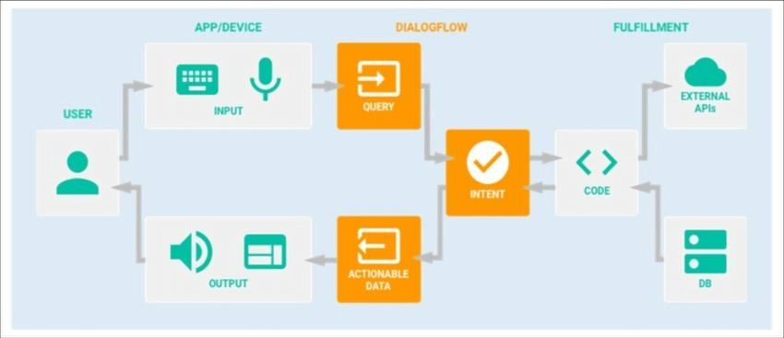

**4.2 Activity Diagram**

Activity diagram is another important behavioral diagram in UML diagram to describe dynamic aspects of the system. Activity diagram is essentially an advanced version of flow chart that modelling the flow from one activity to another activity.

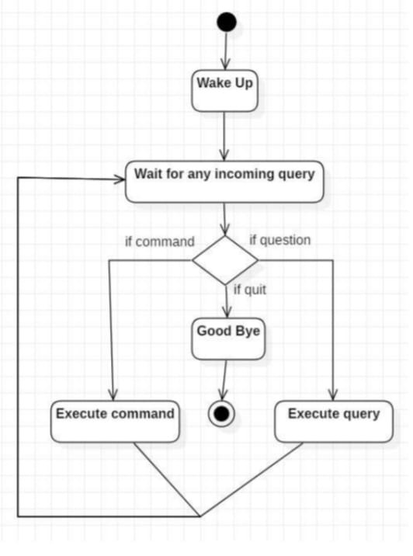

# 4.3 Use case diagram

UML Use Case Diagrams. Use case diagrams are usually referred to as behaviour diagrams used to describe a set of actions (use cases) that some system or systems (subject) should or can perform in collaboration with one or more external users of the system (actors). Hence the Use case diagram is given below for our proposed model.

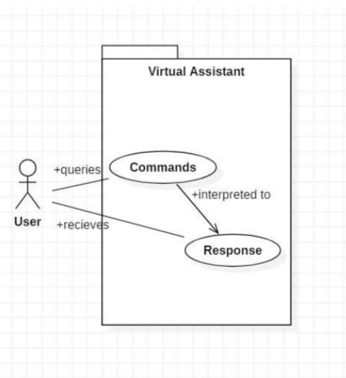

**4.4 ER Diagram**

An entity relationship model describes interrelated things of interest in a specific domain of knowledge.

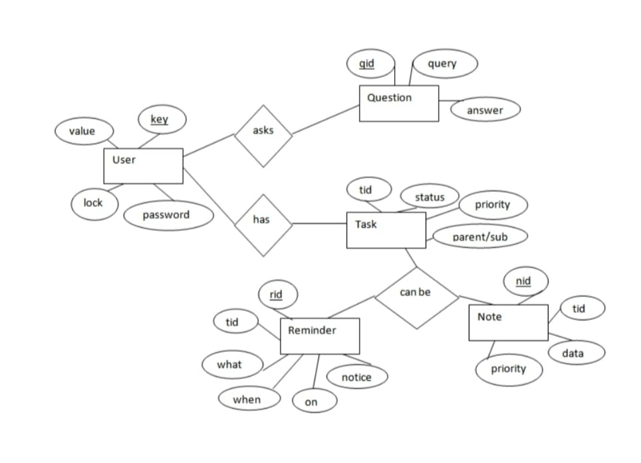

The above diagram shows entities and their relationship for a virtual assistant system. We have a user of a system who can have their keys and values. It can be used to store any information about the user. Say, for key “name” value can be “Jim”. For some keys user might like to keep secure. There he can enable lock and set a password (voice clip). Single user can ask multiple questions. Each question will be given ID to get recognized along with the query and its corresponding answer. User can also be having number of tasks. These should have their own unique id and status i.e., their current state. A task should also have a priority value and its category whether it is a parent task or child task of an older task.

**5. Sequence Diagram**

**5.1 Sequence diagram for Query-Response**

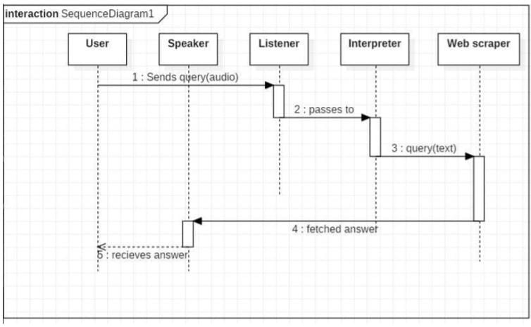

The above sequence diagram shows how an answer asked by the user is being fetched from internet. The audio query is interpreted and sent to Web scraper. The web scraper searches and finds the answer. It is then sent back to speaker, where it speaks the answer to user.

**5.2 Sequence diagram for task Execution**

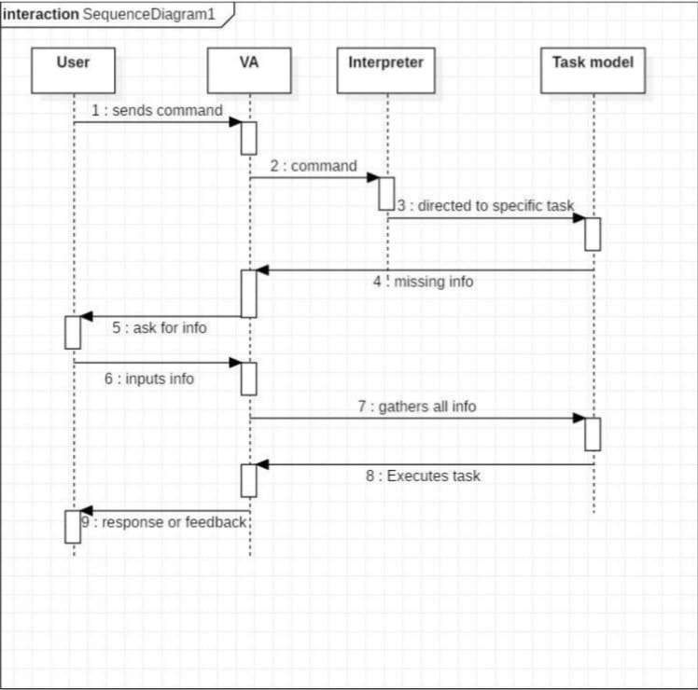

The user sends command to virtual assistant in audio form. The command is passed to the interpreter. It identifies what the user has asked and directs it to task executer. If the task is missing some info, the virtual assistant asks user back about it. The received information is sent back to task and it is accomplished. After execution feedback is sent back to user.

**6.Data Flow Diagram**

**6.1 FLOW CHART**

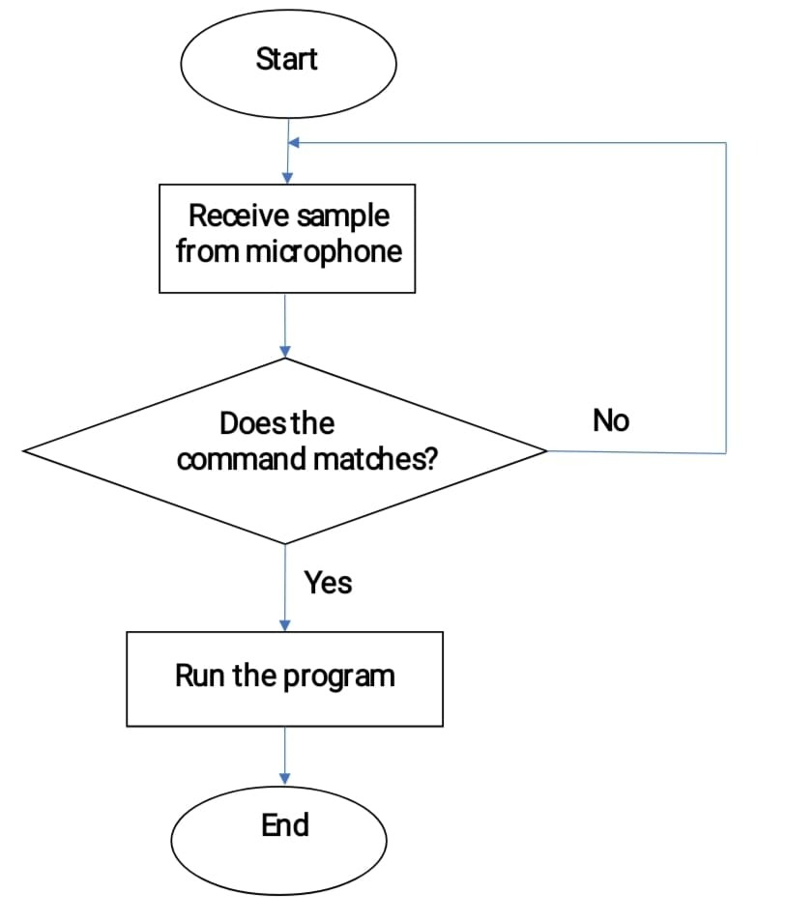

The above diagram shows the flowchart on which the code of DGCT Jarvis is coded.

**6.2 COMPONENT DIAGRAM**

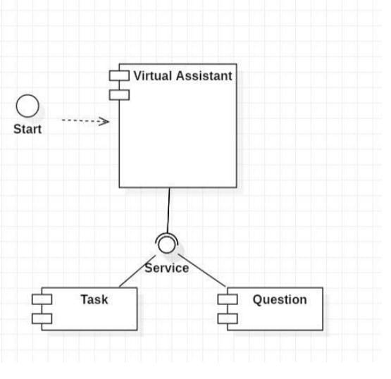

The main component here is the Virtual Assistant. It provides two specific service, executing Task or Answering your question.

**6.3 DEPLOYMENT DIAGRAM**

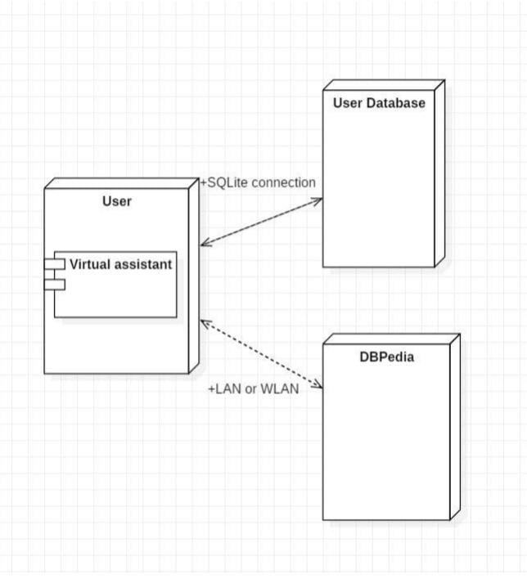

The user interacts with SQLite database using SQLite connection in Python code. The knowledge database DBPedia must be accessed via internet connection. This requires LAN or WLAN / Ethernet network.

7. SOURCE CODE **:**

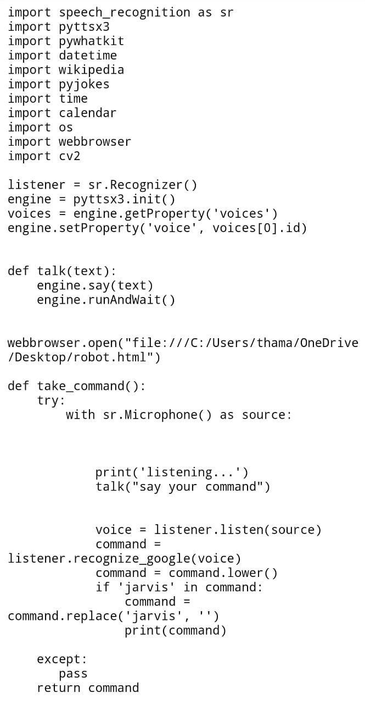

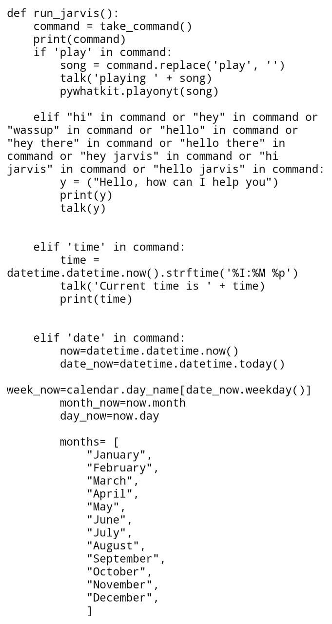

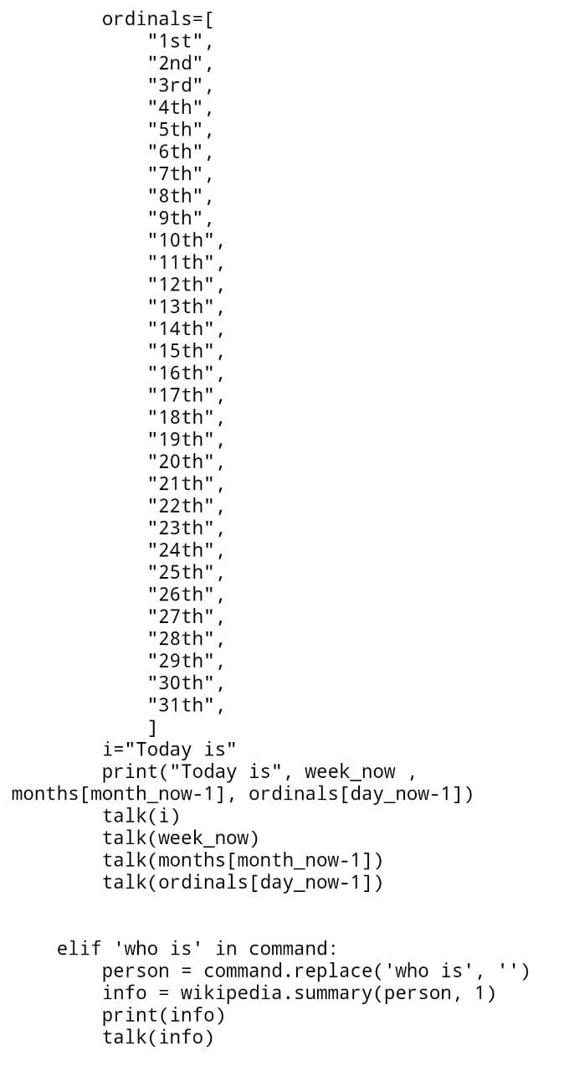

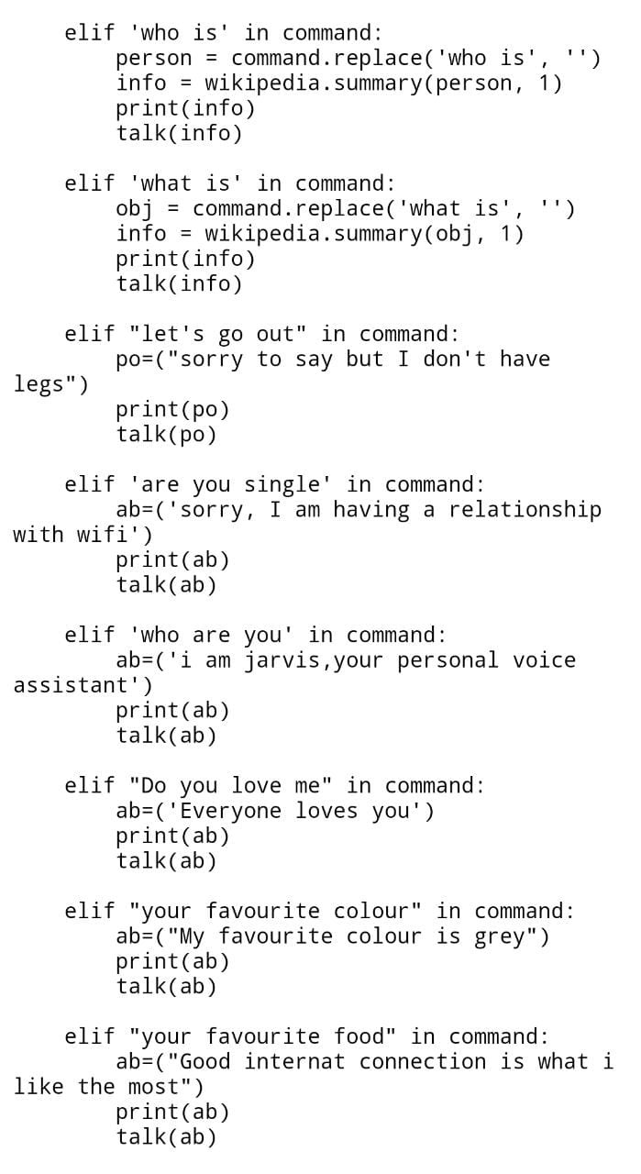

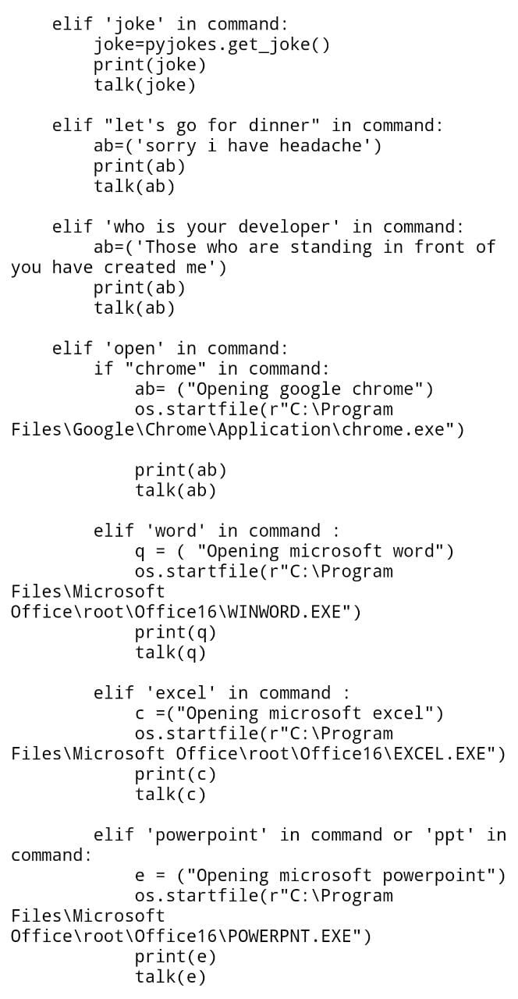

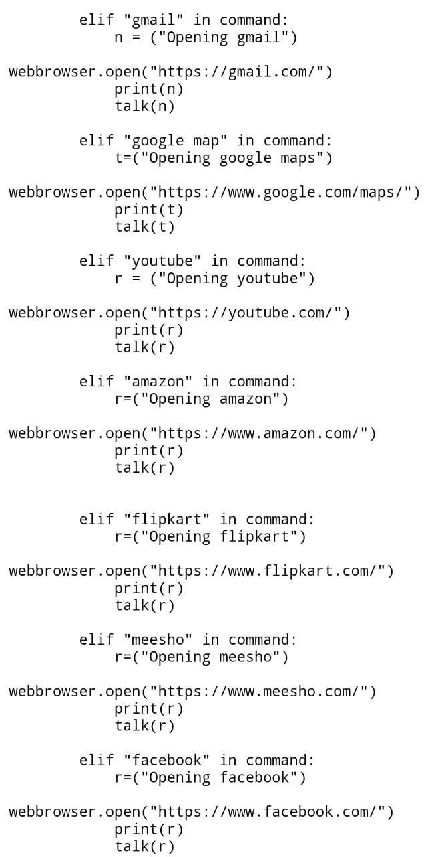

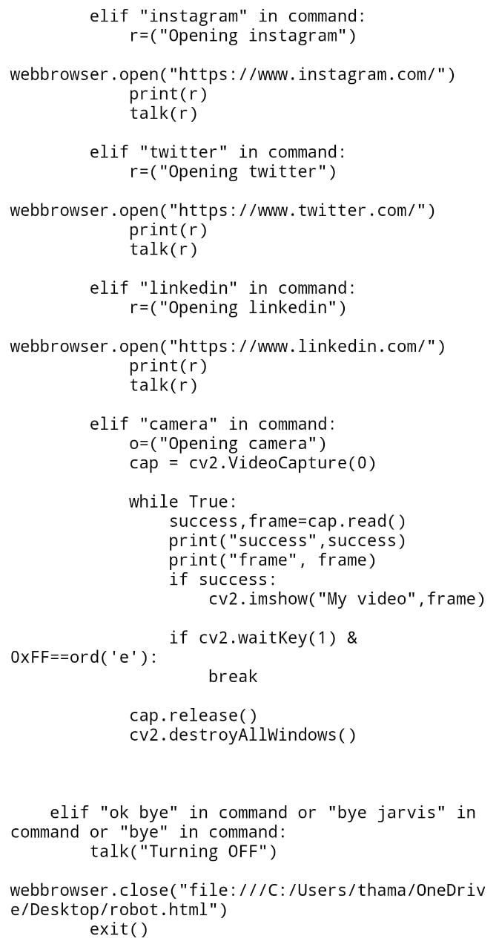

else:

talk (“please say the command again.”)

while True:

run\_jarvis ()

**7**.**2 OUTPUT**

The first page that will appear after running the program is a chat bot page opening in chrome and he will ask for a command and here now you have to give your command by speaking like what you want to do or what you have to do and else.

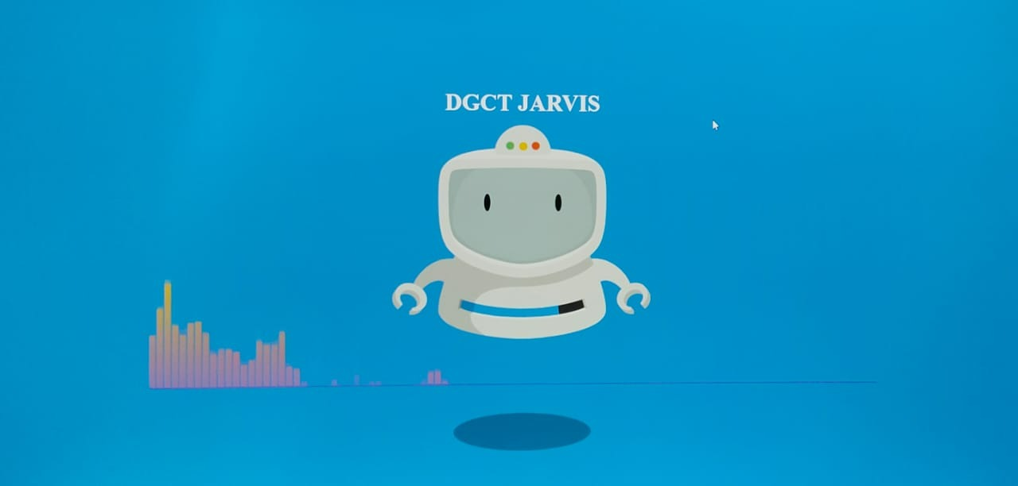

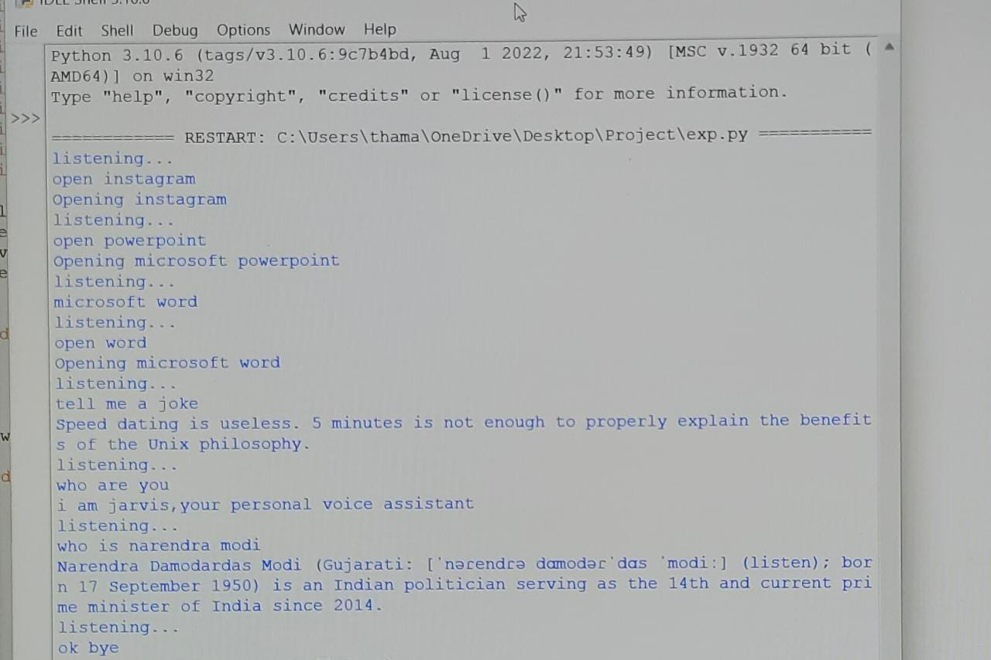

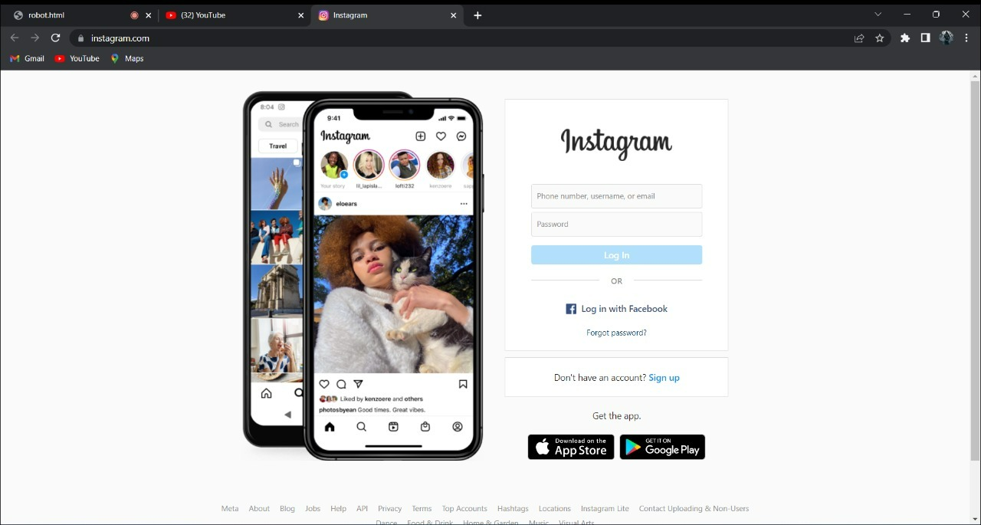

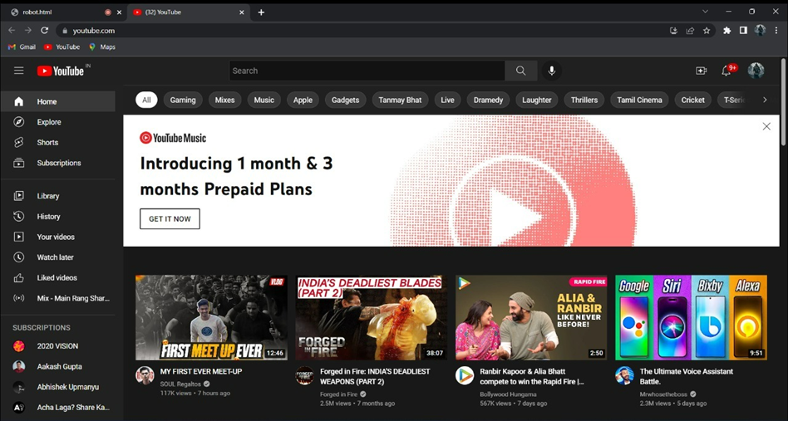

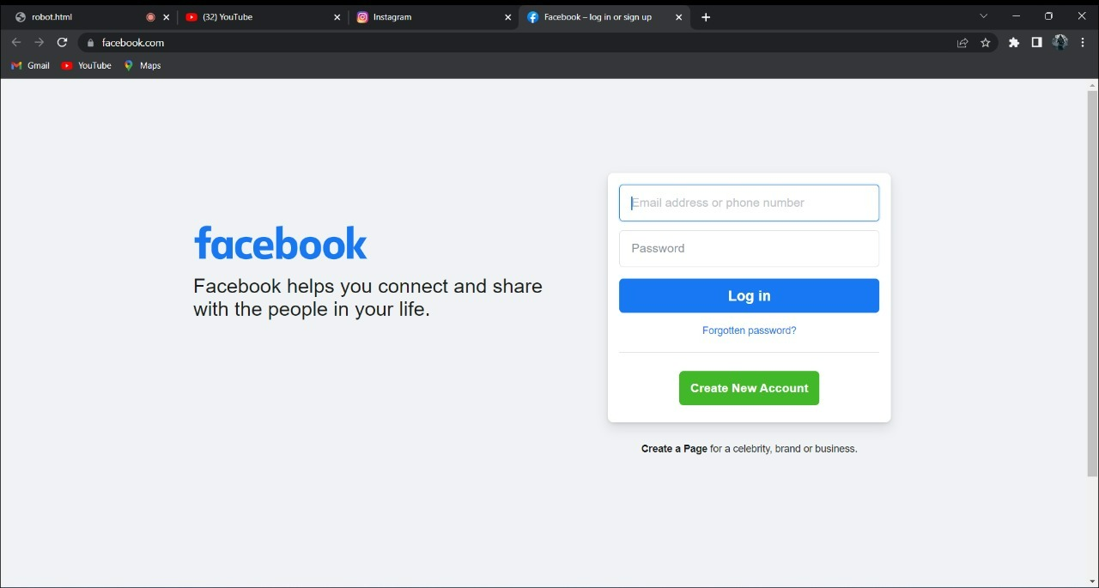

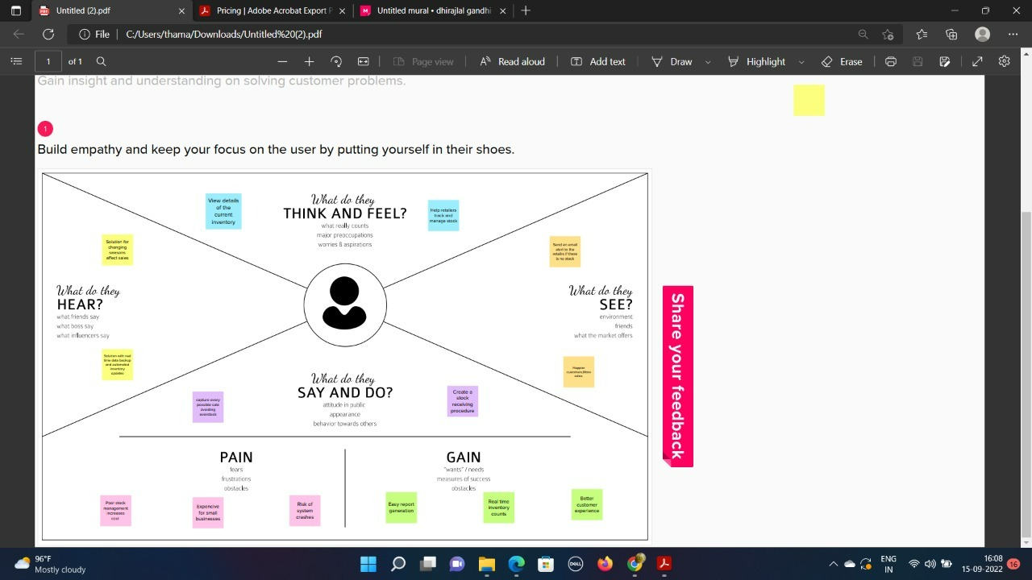

**8 CONCLUSION AND FUTURE ENHANCEMENT**

**8.1** CONCLUSION

JARVIS is a very helpful voice assistant without any doubt as it saves time of the user by conversational interactions, its effectiveness and efficiency. Butwhile working on this project, there were some limitations encountered and also realized some scope of enhancement in the future.

8.2 SCOPE FOR FUTURE WORK

Make JARVIS to learn more on its own and develop a new skill in it.

JARVIS android app can also be developed.

Make more Jarvis voice terminals.

Voice commands can be encrypted to maintain security.

THANK YOU